Title of the Paper [Times New Roman 18, bold]
LAST NAME First Name¹, LAST NAME First Name¹, etc. [max. 5 authors]
[Times New Roman 12]
¹[same number for the same authors’ institution; institution name + complete postal address, written in English]

Abstract
[Times New Roman 10]

Keywords: 5 keywords [Times New Roman 10]
Received: day Month 2022 [Times New Roman 10]

1. Introduction
[Title sections and texts written in Times New Roman 12]

2. Methods
[Title sections and texts written in Times New Roman 12]

3. Results
[Title sections and texts written in Times New Roman 12]

Figures should be coloured with high resolution with descriptive headings. A figure (image, chart, graph, photo, etc.) is placed just after the phrase, in which it is mentioned.

Example:
Figure 1. Results of….(Times New Roman 12)
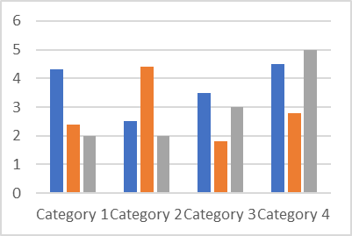
Sources: xxxx (Times New Roman 10)

Each table is written directly in the paper file, using the font Times New Roman 10. Do not introduce tables as images into the text! A table is placed just after the phrase, in which it is mentioned.

Exemple:
Figure 1. Results of….(Times New Roman 12)
Sources: xxxx (Times New Roman 10)

Equations and formulae: An equation must be written directly in the paper file, using Times New Roman 12. Do not introduce equations as images. The order numbers of the equations are written between parentheses, on the right side of the page.

4. Discussion
[Title sections and texts written in Times New Roman 12]

5. Conclusions
[Title sections and texts written in Times New Roman 12]

6. Funding Sources
This work was financially supported by the [Name of Institution] of . . . . . . . [Country], under the Scientific Programme /Grant /Project /Contract / [etc.]: . . . . . . [Name]”, No. . . . . / . . . [year].

7. Bibliographic References
[Each bibliographic reference written in Times New Roman 10]

. . .
[15]

